CineBooking
A Course Project report submitted
in partial fulfillment of requirement for the award of degree

BACHELOR OF TECHNOLOGY
in
SCHOOLOFCOMPUTERSCIENCEANDARTIFICIALINTELLIGENCE
by
Modugula Anuvardhan 2303A58032
Gali Charan Tej 2303A58004

Under the guidance of

Mr. Bura Vijay Kumar
Assistant Professor, School of CS&AI.



SR University, Ananthsagar, Warangal, Telagnana-506371



CERTIFICATE
This is to certify that the project entitled “CineBooking” is the Bonafide work carried out as part of the Web Technologies Course Project for the partial fulfillment of the requirements for the Bachelor of Technology degree at School of Computer Science & Artificial Intelligence, SR University during the Academic Year 2025–2026 under my supervision.

Mr. Bura Vijay Kumar Dr.Ch. Sandeep

Assistant Professor, Head,
SR University School of CS&AI,
Anathasagar, Warangal. SR University.

ACKNOWLEDGEMENT
We express our deep gratitude to our course project guide Mr. Bura Vijay Kumar, Assistant Professor, School of CS&AI, for his timely guidance and constant support. We thank Dr. Ch. Sandeep, Professor & Head, School of CS&AI, for providing the required academic environment. We acknowledge the support of all teaching and non-teaching staff members and our families for their encouragement throughout the project.

ABSTRACT
The Movie Ticket Booking System is a web-based application developed to provide a convenient and efficient platform for users to book movie tickets online. In today’s fast-paced digital world, traditional methods of purchasing tickets from physical counters are becoming outdated due to long waiting times and limited accessibility. This system addresses these challenges by offering an online solution that enables users to browse movies, select theatres, choose show timings, and book seats from anywhere.
The application is designed using modern web technologies such as HTML, CSS, and JavaScript for the frontend, along with Firebase services for backend operations including authentication and database management. The system ensures secure user login, real-time seat availability tracking, and efficient booking management.
Overall, this project improves user experience, reduces manual effort, and provides a scalable platform for future enhancements such as online payment integration and administrative control.

ABOUT THE ORGANIZATION
SR University, located in Warangal, Telangana, is a premier institution known for its innovation-centric curriculum, research facilities, startup ecosystem, and strong emphasis on practical learning. The School of CS&AI offers advanced courses in Web Programming, Mobile App Development, Cloud Computing, and Software Engineering.

INTRODUCTION
With the rapid growth of internet technologies, online booking systems have become an essential part of modern life. People prefer digital solutions that save time and provide convenience. Traditional ticket booking systems require users to visit theatres physically, which can be time-consuming and inefficient.
The Movie Ticket Booking System is developed to overcome these limitations by providing a centralized web-based platform. The system allows users to explore available movies, select their preferred theatres, choose suitable timings, and book tickets easily.
The application integrates frontend user interfaces with backend services to ensure smooth communication and real-time data handling. It enhances accessibility and ensures that users can perform booking operations quickly and securely.

RELATED WORK
Several online booking platforms and entertainment applications exist that provide movie ticket booking services. Popular platforms offer advanced features such as online payments, seat selection, and movie recommendations.
However, many existing systems have certain limitations:
- Some platforms are overly complex with unnecessary features
- Certain applications require high-speed internet and heavy resources
- Some systems lack real-time seat synchronization
- Many are not suitable for learning or academic purposes
The proposed Movie Ticket Booking System focuses on simplicity and efficiency. It provides essential features such as authentication, movie browsing, and seat booking while maintaining an easy-to-use interface. This makes it suitable for both practical implementation and academic understanding.

PROBLEM STATEMENT
In the current scenario, traditional ticket booking systems face several issues that affect user convenience and efficiency.
The major problems include:
- Long queues at ticket counters
- Lack of real-time seat availability
- Limited access to movie and theatre details
- Manual errors in booking management
- Inconvenient and time-consuming process
- No centralized system for managing bookings
These challenges highlight the need for a web-based system that provides a structured, efficient, and user-friendly solution for booking movie tickets online.

REQUIREMENT ANALYSIS

Functional Requirements
The system should support the following functionalities:
- Users should be able to register and create accounts
- Existing users must be able to log in securely
- The system should display available movies with details
- Users should be able to search for movies
- The system should allow selection of location and theatre
- Users should be able to choose show timings
- Seat selection should be interactive and dynamic
- The system should calculate ticket price automatically
- Booking confirmation should be generated
- Users should be able to view booking history
- The system should support logout functionality

Non-Functional Requirements
The system should meet the following quality attributes:
- Performance: Fast loading and response time
- Security: Secure authentication and data handling
- Usability: Simple and user-friendly interface
- Reliability: System should work without crashes
- Scalability: Able to handle more users and data
- Maintainability: Easy to update and modify code
- Availability: Accessible anytime via web browser

Proposed Solution
The proposed solution is a web-based Movie Ticket Booking System designed to provide users with an easy and efficient platform to browse movies and book tickets. The system follows a layered architecture consisting of frontend, backend, and database components.
- Frontend
The frontend of the application is responsible for the visual interface and user interaction.
- Developed using HTML, CSS, and JavaScript
- Uses modern UI frameworks like Tailwind CSS
- Displays movies, theatres, and seat layouts
- Provides interactive booking interface
- Ensures responsive design across devices

- Backend(Servlet Based)
The backend of the system is implemented using Java Servlets, which handle the core application logic.
- Developed using Java Servlets
- Handles user registration and login functionality
- Processes booking requests and seat selection
- Manages session handling for authenticated users
- Communicates between frontend and database
- Controls business logic such as ticket calculation and booking confirmation
- Database
The database is responsible for storing and managing application data.
- Implemented using MySQL (conceptual design)
- Stores user details and login credentials
- Maintains booking history and seat availability
Ensures structured and efficient data management
Key Features
- Secure user authentication system
- Movie browsing and search functionality
- Theatre and showtime selection
- Real-time seat booking system
- Ticket generation with booking details
- User profile with booking history
Responsive and modern UI
SYSTEM ARCHITECTURE
The system is designed using a layered architecture to separate concerns and improve maintainability.

Presentation Layer
- Handles user interface
- Displays movies, booking pages, and forms
- Built using HTML, CSS, JavaScript

Application Layer
- Contains business logic
- Manages booking flow and authentication
- Processes user inputs and responses

Database Layer
- Stores all application data
- Manages user and booking information
Provides real-time updates using Firebase
DATA FLOW DIAGRAM :
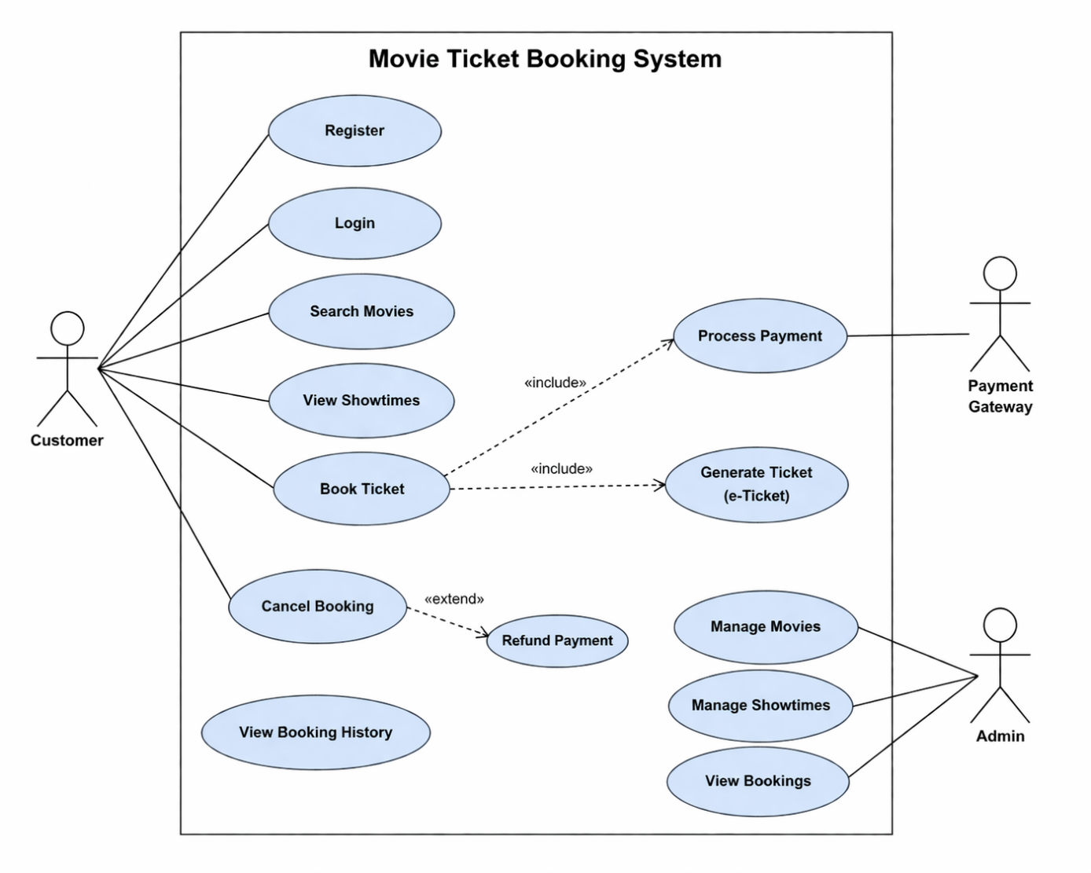
PROCESS FLOW:

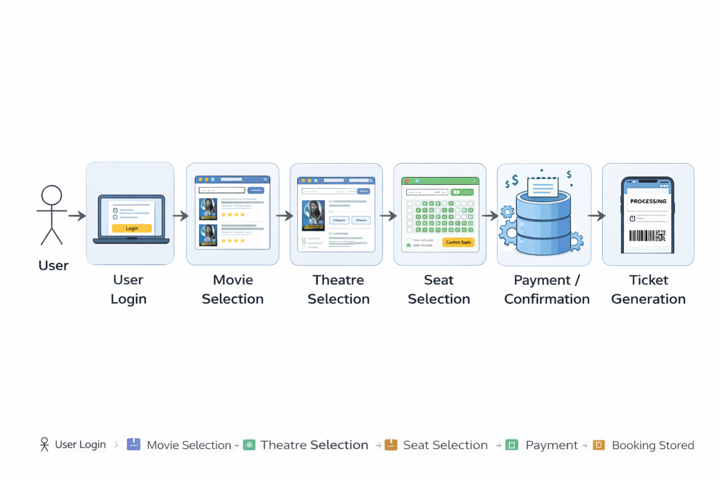
- IMPLEMENTATION
The system is implemented using different modules:

Authentication Module
Handles user registration, login, and password reset functionality.

Movie Module
Displays movie details and allows users to browse and search movies.

Theatre Module
Provides list of theatres based on selected location and available timings.

Seat Selection Module
Allows users to select seats dynamically with real-time availability.

Booking Module
Processes booking, calculates total cost, and generates ticket.

Profile Module
Stores user information and booking history.

RISK ANALYSIS
The development and operation of the Movie Ticket Booking System may involve certain risks that can affect system performance, security, and user experience. Identifying these risks helps in implementing appropriate preventive measures.

Identified Risks
- Session Handling Issues:
Improper session management may allow users to remain logged in even after logout, leading to security concerns.
- Authentication Failures:
Errors in login or signup processes may prevent valid users from accessing the system or allow unauthorized access.
- Real-Time Seat Conflict:
Multiple users may attempt to book the same seat simultaneously, causing booking conflicts.
- Database Synchronization Issues:
Delay in updating seat availability in Firebase may result in incorrect booking status.
- Incorrect Resource Paths:
Wrong paths for images, CSS, or scripts may affect UI display.
- Navigation Errors:
Improper routing between pages like movie selection, seats, and checkout may affect user flow.
- User Input Errors:
Users may enter invalid or incomplete data during login or booking.
- UI Rendering Issues:
Design may not display correctly on different devices or screen sizes.
- Network Issues:
Poor internet connection may interrupt booking process.
- Data Inconsistency:
Improper handling of booking data may lead to duplicate or incorrect records.

Mitigation Strategies
- Implement proper session handling and logout mechanisms
- Use Firebase Authentication for secure login
- Apply real-time database updates to avoid seat conflicts
- Validate all user inputs before processing
- Ensure correct file structure and resource paths
- Test navigation and routing thoroughly
- Design responsive UI for all devices
- Handle network errors with proper messages
- Maintain consistent database updates
- Regular testing and debugging

FEASIBILITY ANALYSIS

Technical Feasibility
- The system is developed using standard web technologies such as HTML, CSS, JavaScript,Java Servlets and Firebase, which are widely supported and reliable.
- Firebase provides real-time database and authentication support, ensuring smooth system operation.
- The technologies used are easy to implement and maintain.
- The modular structure allows easy addition of new features such as payment integration.
- Integration between frontend, backend logic, and database is efficient.
Economic Feasibility
• The project uses free tools like Firebase and Tailwind CSS, so no licensing cost is required.
• Development can be done using existing systems without additional hardware.
• Hosting can be done on free or low-cost platforms.
• Maintenance cost is minimal.
• Overall, the system is cost-effective.

Operational Feasibility
• The application provides a simple and user-friendly interface.
• Users can easily browse movies, select seats, and book tickets.
• The system reduces manual effort and improves efficiency.
• Users can quickly adapt without technical knowledge.

Schedule Feasibility
• The project is completed within the academic timeline.
• Development is done in phases such as design, coding, and testing.
• Each module is implemented step by step.
• Use of simple technologies helped complete the project on time.

PROPOSED SOLUTION
The proposed solution is a web-based Movie Ticket Booking System designed to provide users with a structured and efficient platform to browse movies and book tickets online.
The system follows a layered architecture consisting of frontend, application logic, and database components.

Frontend
- Built using HTML, CSS, and JSP
- Provides a clean and user-friendly interface
- Includes sections like Home, Products, About, and Contact

Backend
- Developed using Java Servlets
- Handles user authentication and request processing
- Manages communication between UI and database

Database
- MySQL is used for data storage
- Stores user details and login information
- Ensures efficient data retrieval

System Features
- Secure user registration and login system
- Display of industrial products with images and details
- Structured sections like Home, About, Products, and Contact
- Smooth navigation within the website
- Session-based login and logout functionality
- Easy access to company contact information

Deployment
- The application runs on Apache Tomcat server
- Developed and tested using Eclipse IDE
- Accessed through a web browser using a local server URL
- Can be deployed on online hosting platforms for public access

SYSTEM ARCHITECTURE
The application is designed using a layered architecture to separate user interface, business logic, and data management.
Presentation Layer:
• Handles the user interface of the system
• Developed using HTML, CSS, and JavaScript
• Displays pages like Home, Movies, Seats, Login, and Profile
Servlet Layer:
- Implemented using Java Servlets
• Processes user actions such as login and booking
• Manages navigation and system flow
• Handles real-time updates
Database Layer:
• Uses Firebase Firestore
• Stores user information and booking data
• Maintains seat availability
• Ensures efficient data retrieval

TECHNICAL ENVIRONMENT & TOOLS
The system is developed using the following technologies:
• HTML, CSS for frontend design
• JavaScript for application logic
• Firebase for backend services and database
• Tailwind CSS for UI design
• VS Code for development
• Web browser for execution
• GitHub for version control

DATABASE DESIGN
The system uses a relational database to store user and application data.
- Table: users
- id: Unique identifier for each user (Primary Key)
- username: Stores user login name
- email: Stores user email address
- password: Stores encrypted user password
This structure ensures secure and efficient storage of user information.

IMPLEMENTATION
The system is implemented using a modular approach to simplify development and maintenance.
Modules Implemented
User Authentication Module:
• Manages user registration and login
• Uses Firebase Authentication
Movie Module:
• Displays movies and details
• Supports search functionality

Theatre Module
- Shows theatres based on location
- Displays available show timings

Seat Selection Module
- Provides interactive seat layout
- Prevents booking of already occupied seats

Booking Module
- Calculates ticket price
- Confirms booking and updates database
- Generates ticket with unique ID

Profile Module
- Displays user details
- Shows booking history

RESULTS
Link:file:///C:/Users/anuva/AppData/Local/Temp/10221ffe-9459-456e-83e5-bb6c5a481ede_WT%20Project.zip.ede/WT%20Project/index.html
Location Selection:
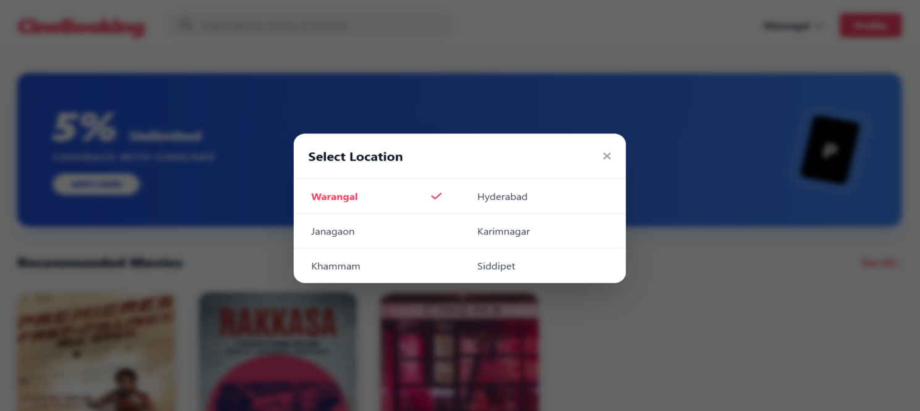
Sign Up Page:
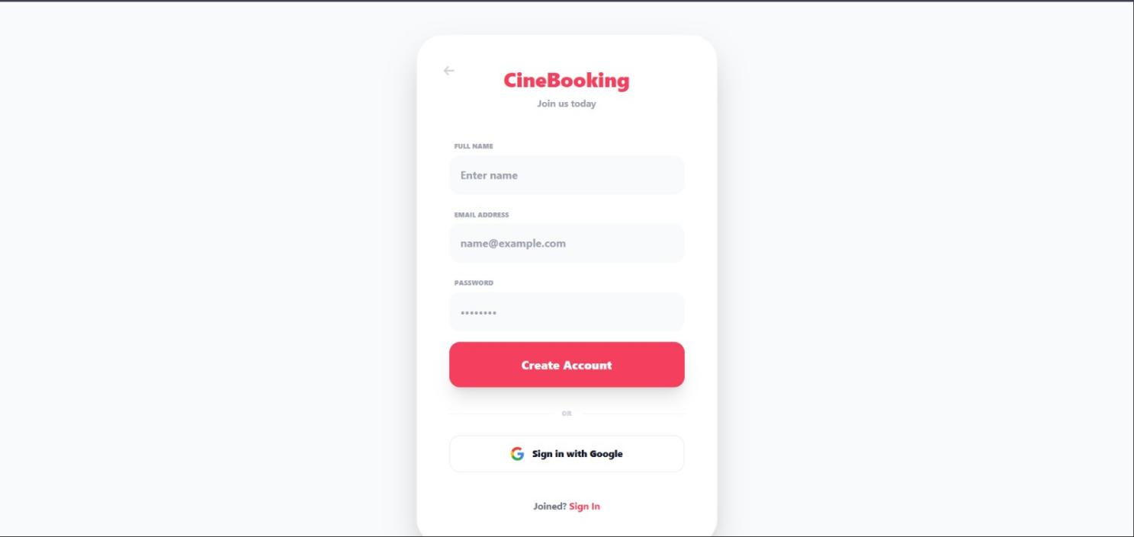
Login Page:
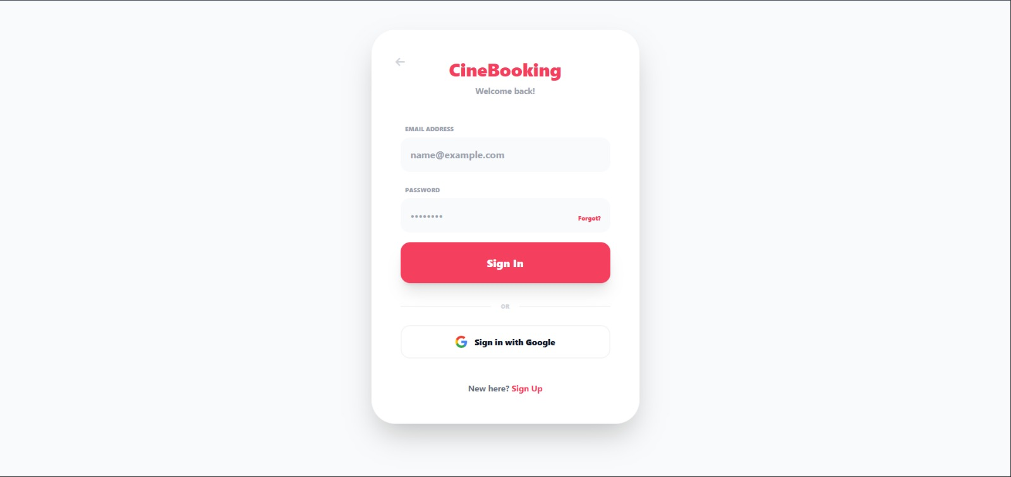

Home Page:
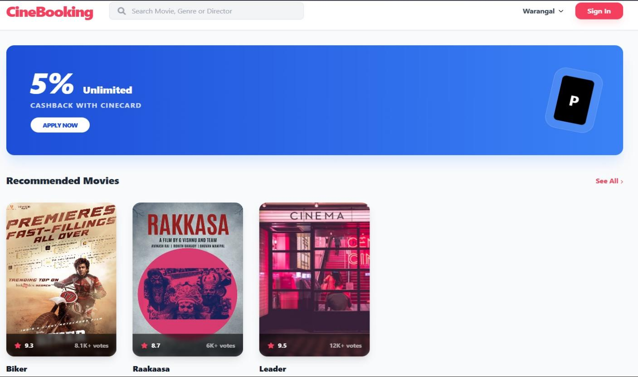
Movie Detail Page :
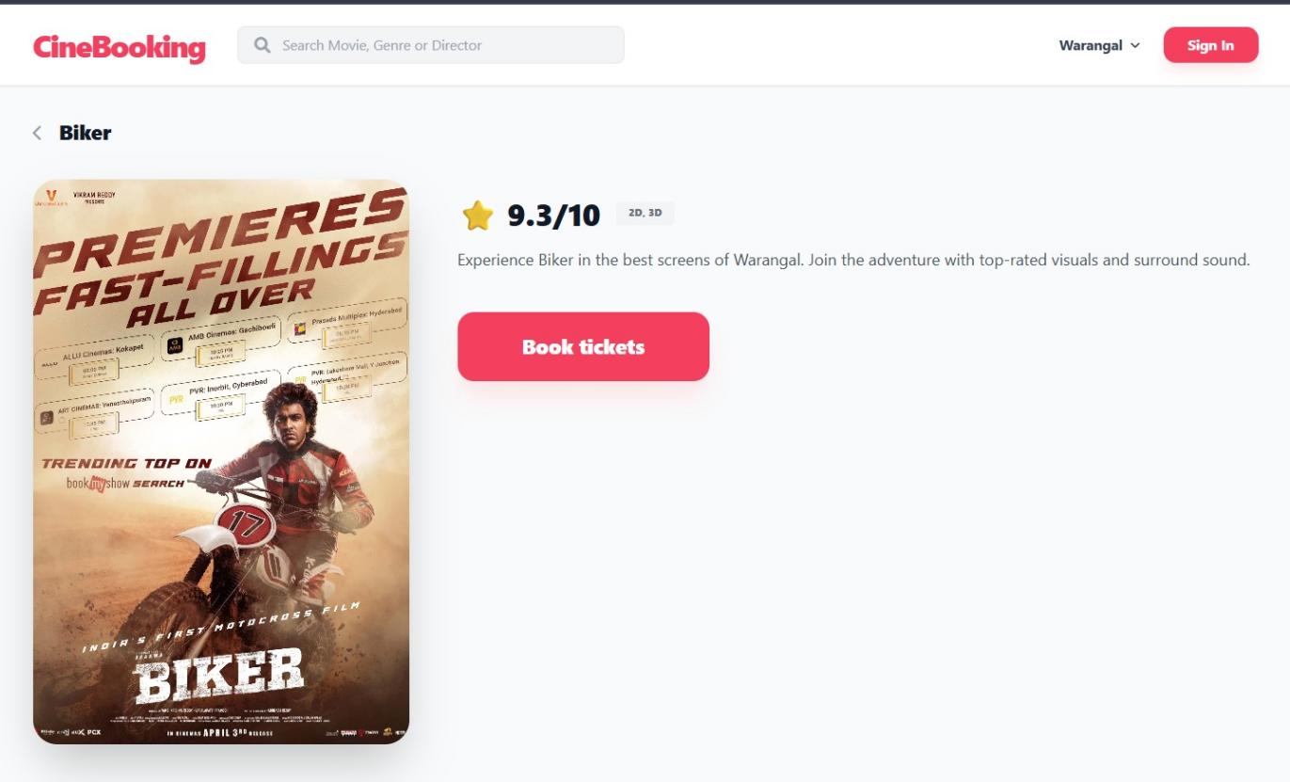

Theatre & Show Timing Selection Page :
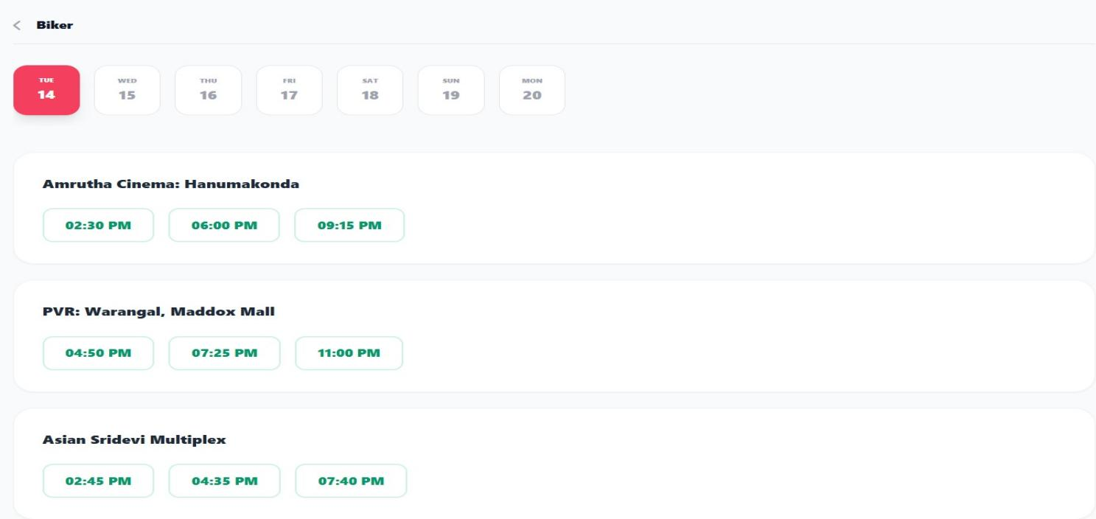

Seat Selection Page:
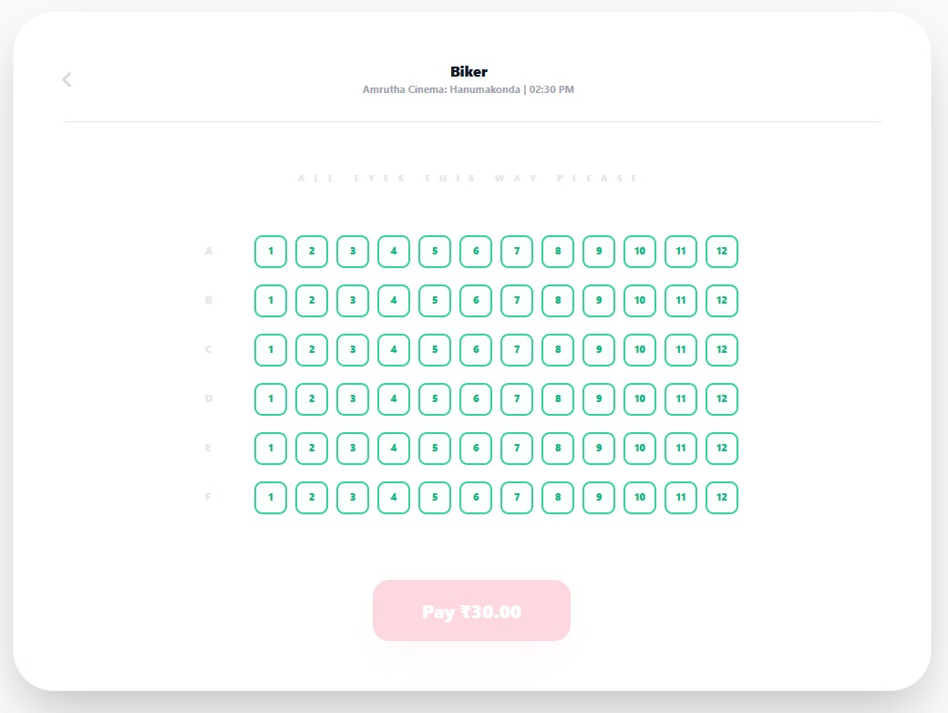

Booking Confirmation Page:
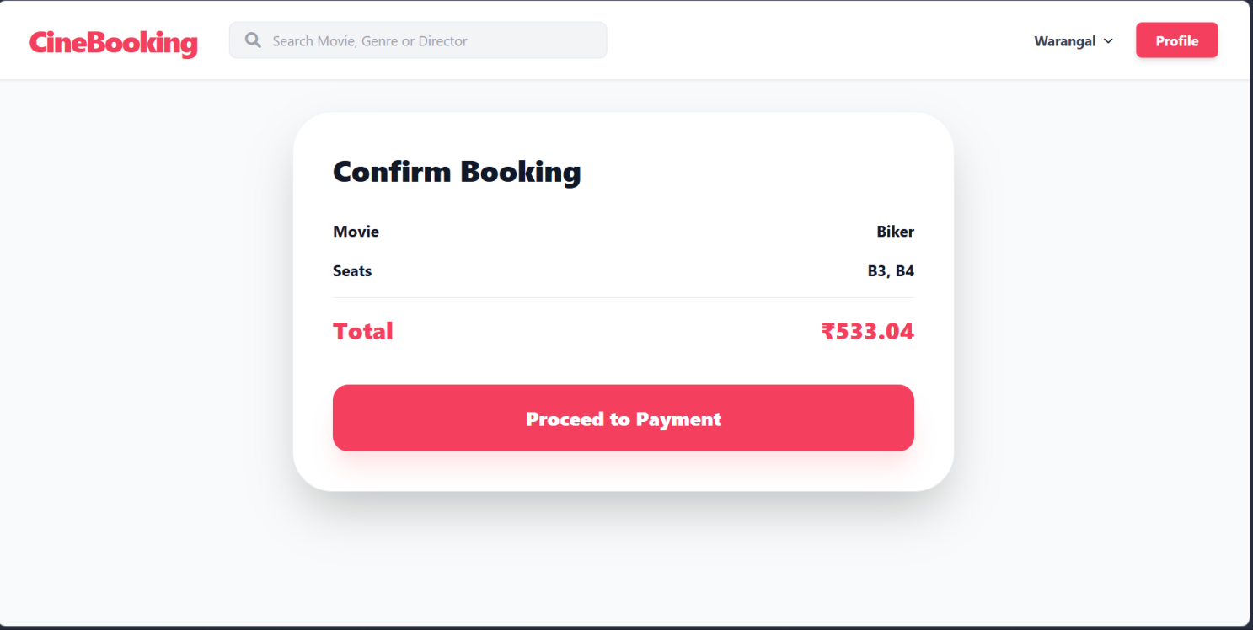
Ticket Generation Page:

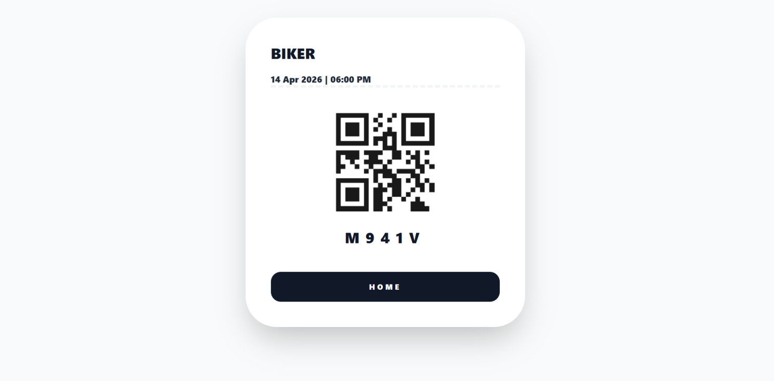

Profile and Booking History:

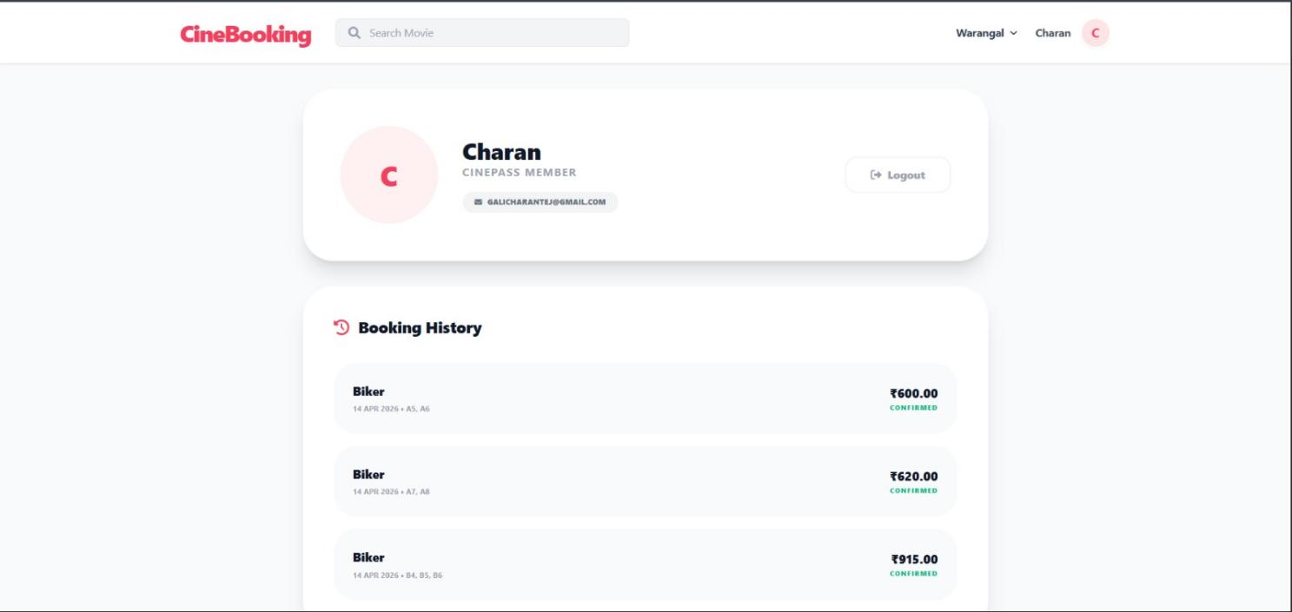

LEARNING OUTCOME
Through the development of this Movie Ticket Booking System, the following concepts were understood:
- Building a complete web application using HTML, CSS, and JavaScript
- Designing and developing responsive user interfaces using Tailwind CSS
- Implementing user authentication using Firebase Authentication
- Managing real-time data using Firebase Firestore database
- Developing dynamic features such as movie selection, theatre selection, and seat booking
- Handling real-time seat availability to prevent duplicate bookings
- Integrating frontend with backend services for dynamic content updates
- Implementing modular structure for better code organization and maintainability
- Managing user sessions and booking history efficiently
- Testing and debugging the application to ensure smooth functionality

CONCLUSION

The Movie Ticket Booking System provides a structured and efficient platform for browsing movies and booking tickets online. It simplifies the traditional ticket booking process by offering a centralized web-based system where users can easily select movies, theatres, timings, and seats.
The project successfully integrates frontend technologies such as HTML, CSS, and JavaScript with backend services using Firebase for authentication and database management. This ensures smooth interaction, real-time data handling, and a user-friendly interface. Features like user authentication, movie display, seat selection, and booking confirmation enhance the overall usability of the system.
The application reduces manual effort, improves the efficiency of ticket booking, and provides a seamless navigation experience for users. The use of real-time database updates ensures accurate seat availability and prevents booking conflicts. The modular design also makes the system scalable and easy to maintain.
Overall, this project demonstrates the practical implementation of a modern web-based application by combining frontend design with backend services, providing an effective solution for online movie ticket booking.

REFERENCES

- Oracle. Java EE and Servlet Programming Guide. Retrieved from: https://www.oracle.com/java/
- W3Schools. Web Development Tutorials for HTML, CSS, and JavaScript. Retrieved from: https://www.w3schools.com
- MySQL. Introduction to MySQL Database System. Retrieved from: https://www.mysql.com
- Apache Foundation. Tomcat Server Usage and Configuration. Retrieved from: https://tomcat.apache.org

